Phase 1 Project Report
Prepared by Hiba and Bilqees
Pharma Sales and Demand Intelligence

1 Problem and goal
Medicine sales and hospital demand are stored in separate files. Sales are recorded one transaction at a time, while hospital demand is recorded by hospital, medicine and month. This makes comparison difficult.
Our goal was to bring these records into one reporting system. We wanted to compare medicine sales, sales money, hospital forecasts, actual medicine use and unmet demand without repeating totals.

Selected data
Source file | Purpose | Original rows
01_master_data.csv | Medicine details | 63
05_pharmacy_sales_data.csv | Sales and pharmacy details | 500,000
06_hospital_demand_data.csv | Hospital details and monthly demand | 27,216

The data contains 63 medicines, 60 pharmacies and 12 hospitals. Original demand covers 2023 to 2025. We selected these three files because they answer the Phase 1 sales and demand questions.

Our approach
We planned the tables in Excel. Python reads the CSV files into PostgreSQL staging, checks and prepares the data, then loads DuckDB reporting tables. SQL produces answers and an HTML dashboard shows the results. Airflow runs these steps in order.
PostgreSQL staging holds the current source snapshot. DuckDB holds the prepared reporting tables and loaded history. Refreshing staging does not delete old facts. We ran the code in VS Code and Airflow in Ubuntu WSL.

2 Understanding our source data
Before writing Python, we used the Excel workbook to decide the business problem, useful columns, reporting tables and transformation rules. The workbook is our design plan. The Python files turn that plan into real database tables.

Why we selected three files
The master file tells us what each medicine is. It has the medicine ID, name, disease category, form, strength, pack information and other product details. The medicine ID connects these details to sales and hospital demand. We keep codes such as GTIN as text so that a zero at the beginning is not lost.
The sales file tells us what pharmacies sold. It has one record for each sales transaction, with the medicine, pharmacy, date, quantity and money values. It also gives pharmacy details and sale categories such as channel, payer and payment method. The dataset has physical pharmacy and e commerce sales. A hospital pharmacy is a pharmacy type.
The hospital demand file tells us what each hospital needed and used in a month. It includes forecasts, requests, approvals, receipts, dispensing, consumption, waste, stock and unmet demand. Hospital details describe the place where this activity happened.
Source detail | Meaning in our project
63 medicines | Seven disease categories with nine medicines each.
60 pharmacies | 28 chain, 20 independent and 12 hospital pharmacies.
12 hospitals | Each reports monthly demand for all 63 medicines.
27,216 original demand rows | 12 hospitals multiplied by 63 medicines multiplied by 36 months.

What we included and left outside this phase
We selected fields that explain sales, demand and their context. We kept IDs needed for links and source checking. A repeated value does not automatically make an ID useless: the same medicine ID is needed on many transactions. A field that adds no useful description or measure can be left out of the reporting design.
Manufacturing, warehouse movements, delivery and sensor events belong to the wider project. Our Phase 1 mart focuses on sales and demand. The files contain sample company data; our work does not establish that these are real records from a named pharmaceutical company.
We did not invent region mappings, free goods or extra revenue fields that the selected sources do not support. We also kept the different levels of detail separate, because a monthly hospital record is not the same thing as a single sale.

3 Reporting design
We used seven dimensions: DimMedicine, DimPharmacy, DimHospital, DimLocation, DimSalesProfile, DimDemandStatus and DimDate. They describe which medicine, place, sale category, hospital status and date a result belongs to.
Fact table | Meaning of one row
FactPharmacySales | One unique sales transaction.
FactHospitalDemand | One hospital, one medicine and one month.

The two facts share Medicine and Date. We compare them only after grouping sales by the same hospital, medicine and month. We do not add sales and hospital consumption together because they may overlap.
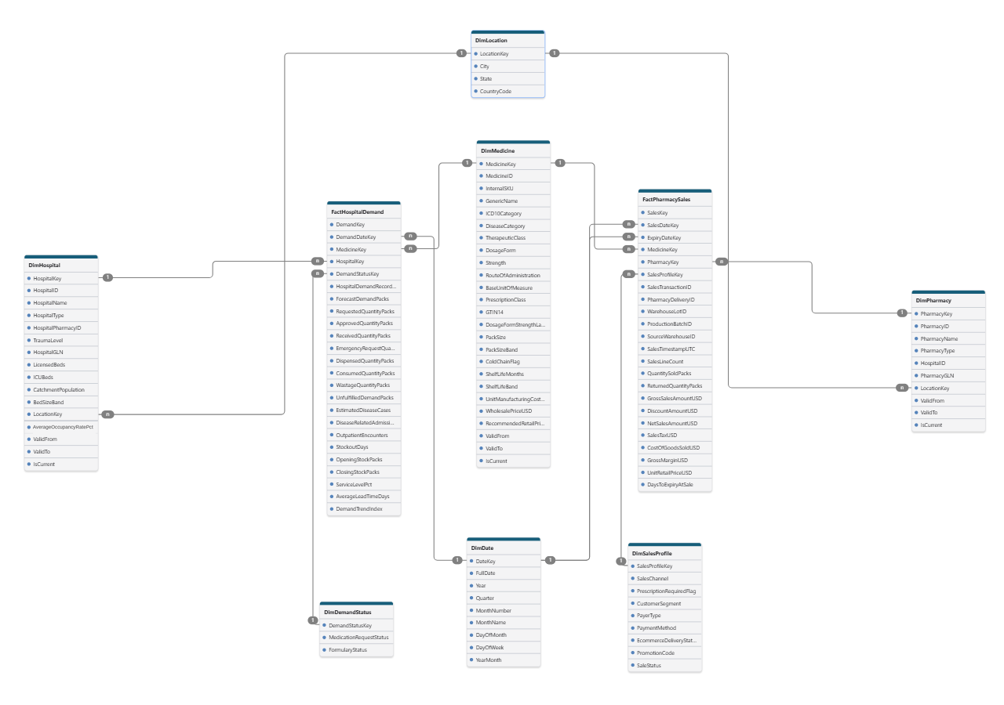
Figure 1. Reporting schema from the final reviewed Excel workbook. The workbook and code contain the full field names.
Source IDs are retained and warehouse keys link the tables. Type 1 handles corrections. Type 2 keeps dated versions for selected real changes. Monthly stock balances are not added across months. Prices and percentages are not summed.

4 How the tables and calculated fields work

Dimensions explain the facts
Dimension | Question it helps us answer
DimMedicine | Which medicine, disease category, form and strength?
DimPharmacy | Which pharmacy and pharmacy type?
DimHospital | Which hospital and hospital characteristics?
DimLocation | Which city, state and country?
DimSalesProfile | Which channel, payer, payment method and sale status?
DimDemandStatus | Which request and formulary status?
DimDate | Which day, month, quarter and year?

A primary key identifies one row in a table. A foreign key points to the matching dimension row. For example, MedicineKey in a sales fact points to MedicineKey in DimMedicine. We can then show the medicine name beside the sales total without writing the name into every fact record.
The two fact tables share Medicine and Date. Location is linked through Pharmacy and Hospital. Because two facts share dimensions, the whole design is a fact constellation. Its Location branch is a small snowflake. The schema picture shows these connections.

Derived means made from existing data
Field or rule | Simple example
Date labels | From 2025 03 15, derive year 2025 and month March.
DaysToExpiryAtSale | If expiry is 30 days after the sale, store 30.
SalesLineCount | Store 1 for each sale row, then add it to count sales.
Warehouse keys | Create internal keys and find the matching dimension key.
Size bands | Turn a numeric size into a named group using stated project cutoffs.

A derived value is calculated during preparation. It is not a new original source column. We keep source money and quantity fields and check them. For example, net sales should match gross sales minus discount. Hospital closing stock should match opening stock plus receipts minus dispensing minus waste.

Keeping history
Type 1 fixes a wrong description in place. Type 2 keeps an old dated version when a selected real detail changes, such as a pharmacy type. ValidFrom, ValidTo and IsCurrent describe those versions. A fact uses the version that applies on its date. Key 0 is an Unknown row for missing links; it is not another real medicine or hospital.

5 Data preparation and loading
Main file | Purpose
ingest.py | Read source files and load PostgreSQL staging.
model.py | Check records and load DuckDB dimensions and facts.
run_pipeline.py and sql files | Run the pipeline directly and produce SQL answers.
generate.py | Add the two synthetic demo batches.
api_visuals.py and sales_demand_visuals.py | Connect the Windows steps and run them through Airflow.
make_dashboard.py and dashboard_template.html | Build the business charts from SQL results.

We checked missing and duplicate IDs, valid dates, numeric values and matching keys. We checked sales amounts and the hospital stock balance. Text codes retain their leading zeros. Invalid mart data stops the load and rolls back its transaction.
Derived fields include warehouse keys, calendar labels, SalesLineCount and days to expiry. Pack and hospital size bands use stated project cutoffs. Source numbers are kept. Repeated source IDs are not loaded as new facts.
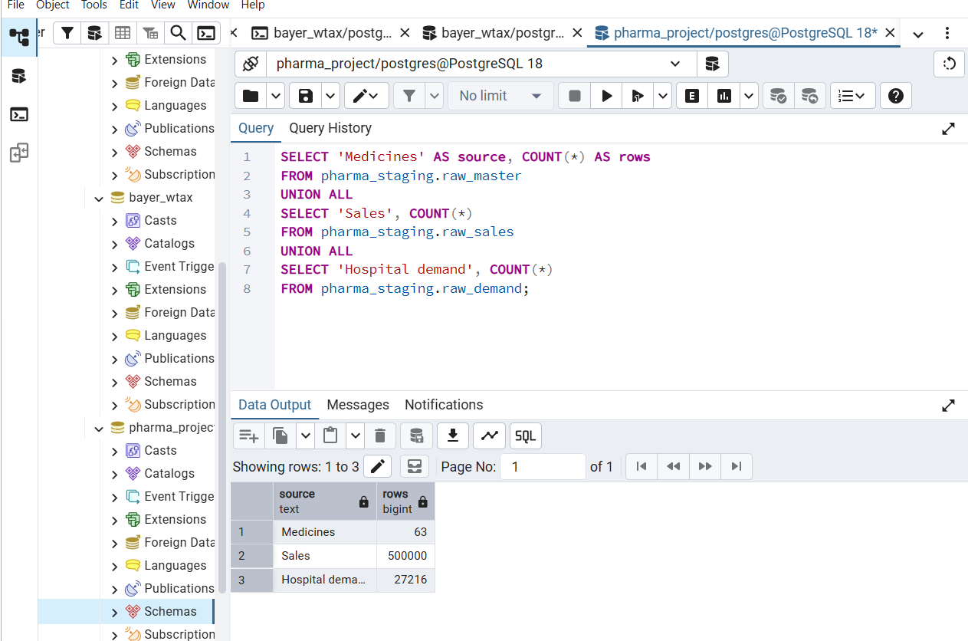
Figure 2. The original staging counts were 63 medicines, 500,000 sales and 27,216 hospital demand records.
The separate File Purpose Guide lists the supporting files, outputs and older versions.

6 Automated workflow
We used api_visuals.py to let Airflow request the Windows Python steps. The workflow file is airflow_dags/sales_demand_visuals.py. We copied it into the Ubuntu Airflow DAG folder and triggered the workflow.
Task | Result
ingest_into_postgres | Source snapshot loaded into PostgreSQL.
validate_transform_and_load | Checked records loaded into DuckDB.
execute_three_questions | SQL answers saved as result CSVs.
refresh_dashboard | Dashboard rebuilt from the answers.

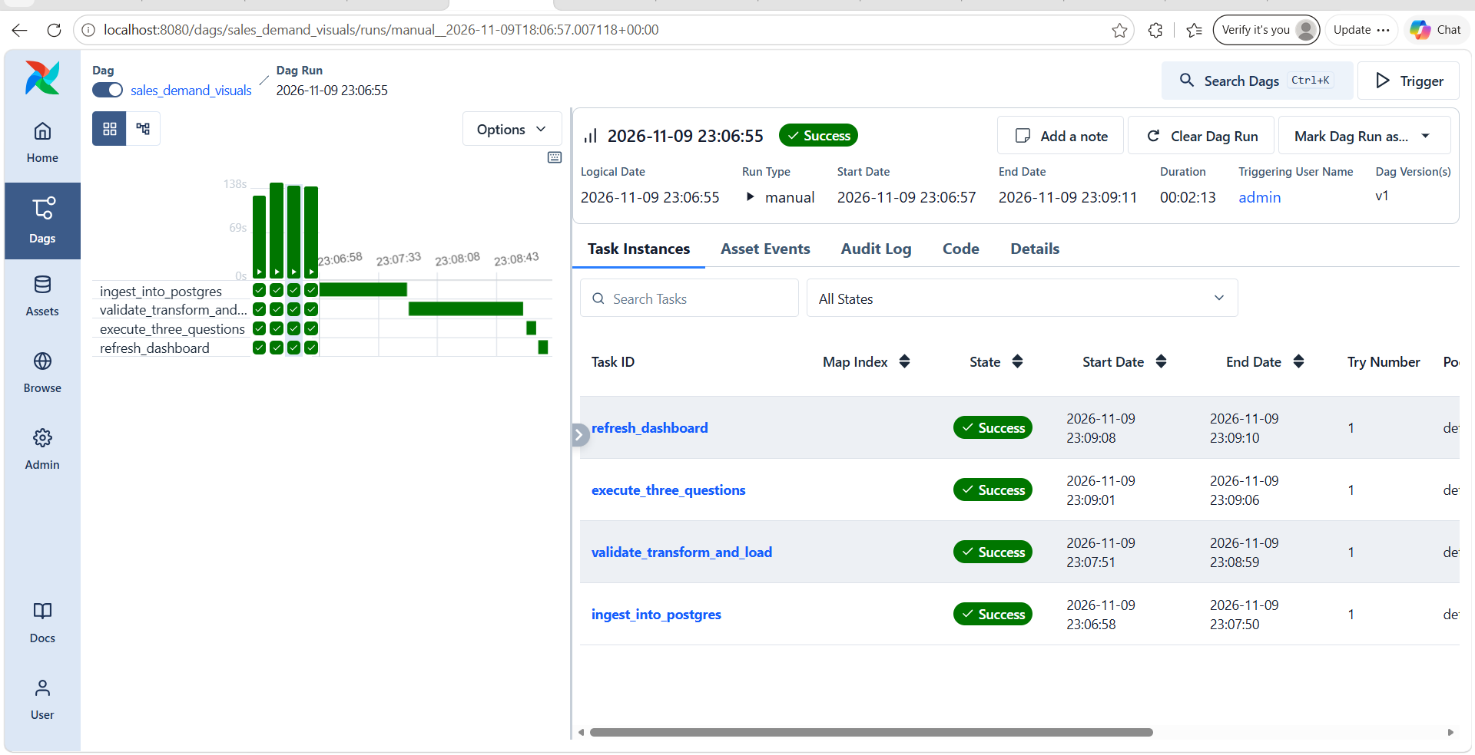

Figure 3. Airflow successfully completed all four tasks: loading source data, preparing reporting tables, running SQL questions and refreshing the dashboard.
All four tasks are green. This shows the workflow completed from source ingestion to dashboard generation. The API and Airflow servers must stay running during execution. The dashboard file is rebuilt automatically; opening or reloading the browser is manual.

7 Questions and business dashboard
Our three SQL questions are:
1. Which medicines earn the most net sales and sell the most packs, by month, channel and city?
2. How do hospital forecasts compare with consumed packs and recorded unmet demand?
3. For the same hospital, medicine and month, how do hospital pharmacy sales compare with hospital demand?
The SQL files are in sql and the three answer CSVs are in results. make_dashboard.py uses these answers with dashboard_template.html to create results/dashboard.html.
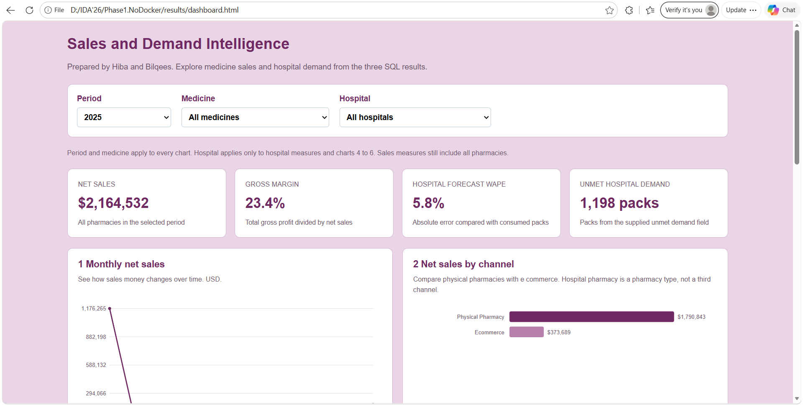

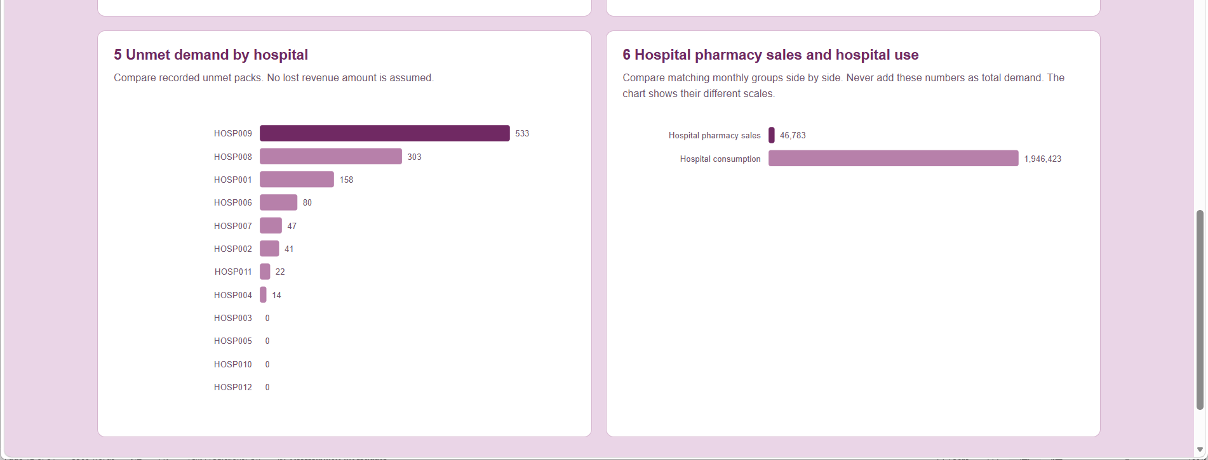
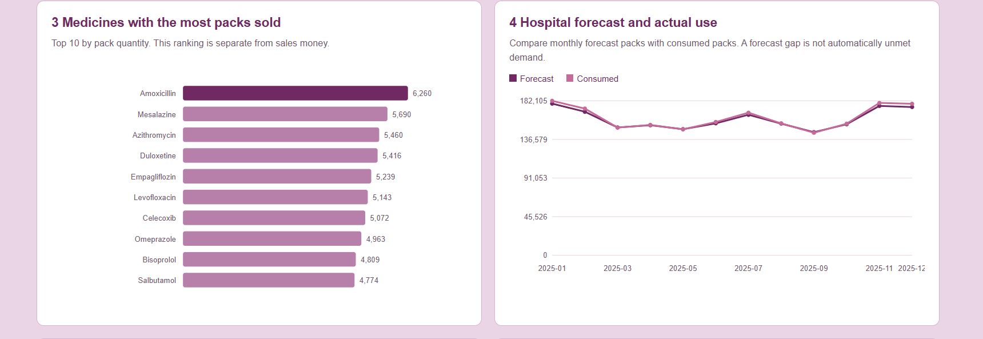

Figure 4. Thedashboard with 2025 selected.
For 2025, the dashboard shows net sales of $2,164,532, gross margin of 23.4 percent, forecast WAPE of 5.8 percent and 1,198 unmet packs. The charts compare sales trends, channels, top medicines, forecast and consumption, and unmet demand.
Year and medicine filters apply to all charts. Hospital applies only to hospital measures. New demo records are in 2026, so select 2026 or All years to see their effect. A net sales card shows money, not a transaction count.

8 Reading the SQL answers correctly

Question 1 Sales by medicine month channel and city
We use FactPharmacySales with Medicine, Pharmacy, Location, SalesProfile and Date. We group matching records and add quantities, net sales and margin amounts. This lets us compare medicines, months and channels. The result is saved as 01_sales_by_medicine_month_channel_city.csv.
A count of 500,000 means 500,000 sale records. It does not mean 500,000 packs or $500,000. Packs come from quantity fields. Money comes from sales amount fields. These three measures answer different questions.

Question 2 Hospital forecast and actual use
We use FactHospitalDemand with Medicine, Hospital and Date. Forecast packs show the expected need. Consumed packs show recorded use. Unfulfilled demand shows the supplied unmet demand measure. The result is saved as 02_hospital_forecast_consumption.csv.
Forecast WAPE compares the forecast with consumption. We first find the absolute forecast error for each hospital, medicine and month. We add these errors, divide by total consumed packs, and multiply by 100. If total error is 10 packs and total use is 200 packs, WAPE is 5 percent. When total consumption is zero, the percentage cannot be calculated in the normal way.

Question 3 Compare sales and hospital demand
We first group hospital pharmacy sales by hospital ID, medicine ID and month. We separately prepare hospital demand at that same level. We then match the grouped results. The result is saved as 03_sales_and_demand_side_by_side.csv.
For example, one hospital may have ten sales of a medicine in March and one demand record for that medicine in March. Joining the ten raw sales directly to that demand record can repeat its demand amount ten times. Grouping the sales first prevents that error.
Measure | How we handle it
Sales and consumption | Show beside each other; do not add them into one demand total.
Monthly stock | Compare balances over time; do not add every month into one stock balance.
Prices and percentages | Use a suitable rate or average; do not sum them.
Overall gross margin percent | Total margin amount divided by total net sales, multiplied by 100.

The SQL result CSVs are answer tables, not replacement source files. They let us inspect the answers in Excel and supply the dashboard. The dashboard reads these files after SQL has run, so new source records must pass through loading and SQL before they appear in the charts.

9 Two data refreshes
We used generate.py to prepare a separate demo copy, then generate January and February 2026 records. Each batch adds 1,000 sales and 756 hospital demand rows. Original source files and old fact records are retained.
Stage | Sales records | Demand records
Baseline | 500,000 | 27,216
Refresh 1 | 501,000 | 27,972
Refresh 2 | 502,000 | 28,728

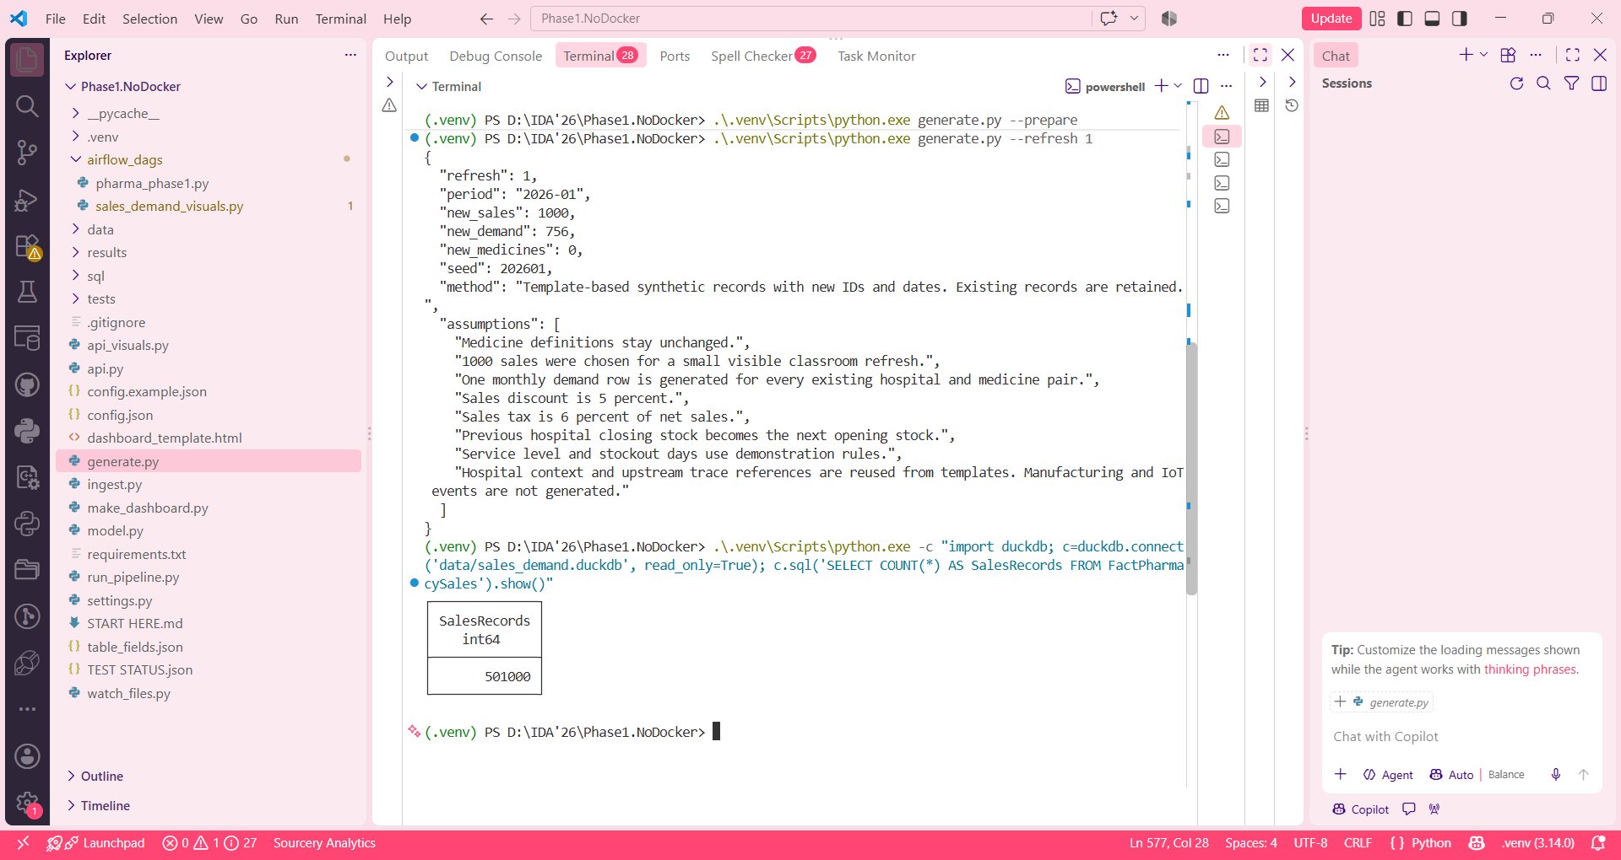
Figure 5. First batch generation and the loaded sales count of 501,000.
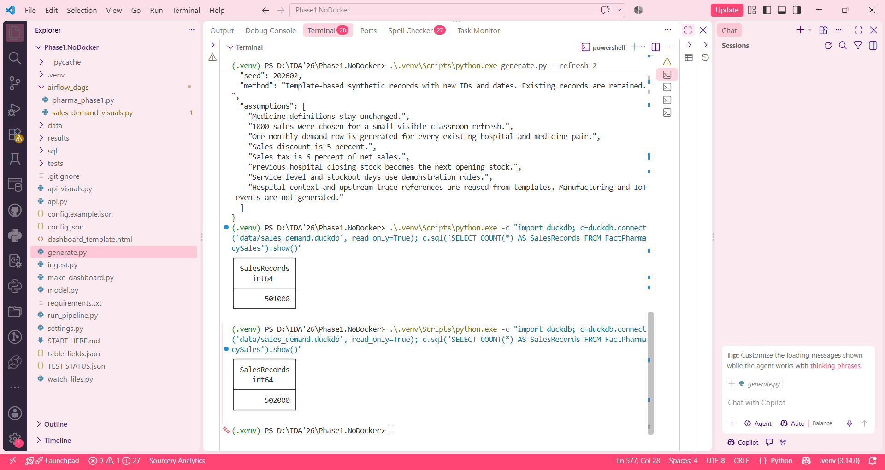
Figure 6. Second batch generation and the later sales count of 502,000.
We ran Airflow after each batch. A separate read only query of the actual database confirmed 502,000 sales and 28,728 demand records. The short data generation report contains the rules, assumptions and seeds.

10 Monitoring and conclusion

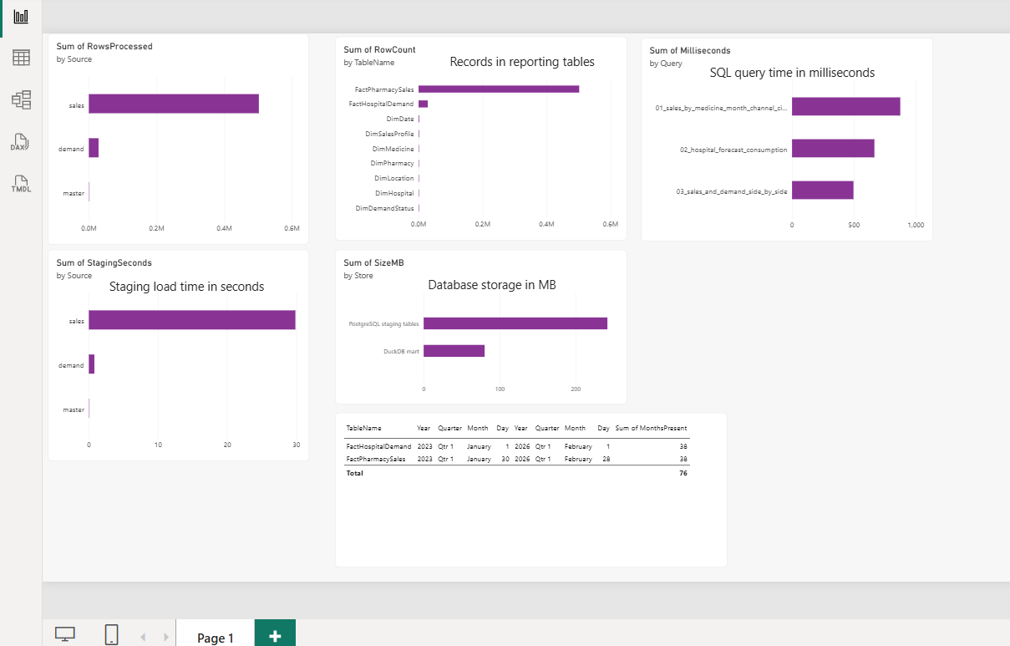

Figure 7. Power BI dashboard showing record counts, loading time, SQL query time, database size and date coverage.

We ran export_monitoring.py to save the technical measurements as CSV files. We imported these files into Power BI and made the following charts.
- Source records processed
This chart shows how many records came from each source file. The sales file has the most records, followed by hospital demand and medicine master data.
- Records in reporting tables
This chart shows the number of rows in each DuckDB dimension and fact table. FactPharmacySales has the most rows because it stores individual sales. FactHospitalDemand stores monthly hospital demand.
- SQL query time
This chart shows how long each of our three SQL questions took to run and return its results. The time is shown in milliseconds. A smaller bar means the query finished faster in this measurement.
- Staging load time
This chart shows how many seconds each source took to load into PostgreSQL staging. The sales file took the longest because it contains many more records.
- Database storage
This chart compares the space used by the PostgreSQL staging tables and the DuckDB reporting database. The size is shown in MB. These stores contain different structures, so this is a storage comparison.
- Date coverage
This table shows the first date, last date and number of months present in each fact table. Both facts cover 38 months, including the two added months in 2026.

Conclusion

We built the Phase 1 reporting pipeline using the Excel design, PostgreSQL staging, DuckDB tables, SQL and Airflow. The successful run shows the steps work together. Two refreshes increased the sales count to 502,000 while keeping old records. The dashboard gives a common view of medicine sales and hospital demand.
The remaining evidence is the completed monitoring page, watcher trigger message and a dashboard view that includes 2026. Generation remains manual and covers the Phase 1 sources; the wider seven-file generation requirement is separate. We do not claim an improvement in real shortages or forecast accuracy from this classroom demonstration.
The File Purpose Guide explains each project file and its job. Full selected fields and the schema are recorded in the final Excel workbook.

